

**Introduction**:

**Title**: Lemon Robotics Website Frontend documentation

**Guide to design website documentation**

<https://highrise.digital/blog/web-specification-guide/>

**Overview**:

This website is dedicated to showcase Lemon Robotics company products and services from a potential customer POV (*point of view*).

*A brief intro about Lemon robotics products ….*

All Pages are properly designed, responsive, creative and interactive in order to give users an enriching & pleasant experience.

A general visitor of this site may include robotics / automation engineers, …. *Give more example of target market*

**Main Project Technology & dependencies**:

🡪 Vite (*JavaScript Build tool to simplify building and developing Front-end web applications*)

🡪 React (*open -source JavaScript Library for building Frontend*)

🡪 react-router-dom (*A npm package to implement dynamic routing; display pages and allows users to navigate them*)

🡪 MUI (*A React – component library that offers a suite of free UI tools*)

🡪 Axios (*A promise based HTTP client that can be used to make HTTP requests and handling responses*)

🡪 formik (*Free and open source React based JavaScript library for designing, managing and validating complex form designs*)

🡪 yup (*A JavaScript schema builder for value parsing and validation; used to validate the form values stores in a single object*)

🡪 Lottie-react (*A react component for Lottie – player which is a high quality JSON – encoded animation*)

🡪 Swiper (*A free and open source JavaScript library that creates modern touch sliders with hardware – accelerated transitions* )

🡪 react- - countup (*A react component library that can animate counting up or down a number*)

Source (*src*) Directory structure:

As of 17 dec 2023:

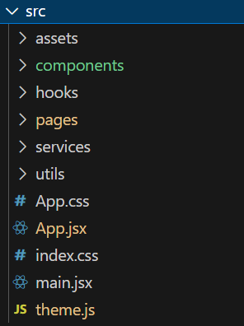

🡪 *assets* (*Store static documents like images, videos, animations & svg files*).

🡪 *components* (*Contain reusable components that can be imported and used through entire application*)

**Phases**:

* Basic Website -- current project
* Add Employee Portal
* Add E – commerce